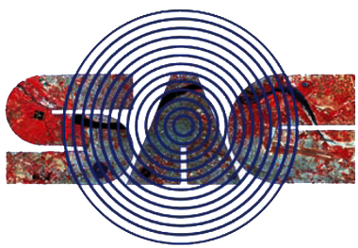

Automation & Development of Calibration & Maintenance
Computerized Management Information System
(CMCMIS)

Report submitted for completion of internship
(Scientific Research and Training)
Programme of Space Applications Centre
Submitted by
Deep Rajubhai Sorathiya
23BCE332
B.Tech. (Computer Science & Engineering)
Under the guidance of
Shri. Shreeyansh Kumar Golhani
SCI/ENGR – SF
TIMCD/EFMG/ESSA
Space Applications Centre, (ISRO) Ahmedabad
Institution
Institute of International Studies, Nirma University

Ahmedabad – 382481
Gujarat

TIMCD-EFMG-ESSA
Space Applications Centre (ISRO)
Ahmedabad, Gujarat

ACKNOWLEDGEMENT
The internship opportunity I had with TEST INSTRUMENTS MAINTENANCE AND CALIBRATION DIVISION in ELECTRONICS SUPPORT SERVICE AREA (ESSA), SAC, ISRO was a great chance for learning and professional development. I consider myself fortunate to have been provided with this opportunity and to have met so many talented professionals who guided me at every stage of this project.
With this in mind, I would like to express my deepest gratitude to my mentor at SAC-ISRO,
SRI. SHREEYANSH KUMAR GOLHANI (SCI/ENGR-SF) who — despite his demanding responsibilities — consistently took time to guide me, provided access to the division's operations, and extended every courtesy during the training period.
I am also grateful to the SRI. ARUN BINDAL (GROUP DIRECTOR, SCI/ENGR-G ESSA-EFMG),
SRI. B.A. PATEL (HEAD, SCI/ENGR-SGESSA-EFMG-TIMCD) for giving me the opportunity to work with SAC ISRO. Also, grateful to SRI. RAHUL AGARWAL (SCI/ENGR-SD), SRI. MODHWADIYA VIJAYKUMAR ARABHAM (TECH. OFFICER-D), SRI. CHAUDHARY NAYAN RAVIBHAI (TECH. OFFICER-C), SRI. SUDHEER KUMAR (TECH. OFFICER-C), SRI. RAVINDRA KALYA VASAVE (TECHNICIAN-D), SRI. CHAVDA BRIJESH AMBALAL(TECHNICIAN-G), for their precious and thoughtful guidance, which was invaluable both theoretically and practically throughout the engagement.
Furthermore, I would like to thank SRI. MAYANK SINGH RANA (SCI/ENGR-SD) and SRI. AKHILESH SHARMA (HEAD, SCI/ENGR-SG SRSA-SQAG-GSQAD) for exceptional support during whole life cycle of software development.
I perceive this opportunity as a major milestone in my career. I will continue to build on the skills and knowledge acquired here, and I look forward to future collaboration.

1. Introduction
The Space Applications Centre (SAC) at ISRO relies on its Test Instruments Maintenance and Calibration Division (TIMCD) to ensure that every piece of test and measurement equipment used across the centre is accurately calibrated, properly maintained, and correctly documented. Historically, the workflows governing this activity — raising job requests, executing calibration or maintenance work, generating NABL-accredited certificates, and maintaining equipment history — were managed through a digitalised legacy software.
While this legacy infrastructure captured core master data. The absence of a role-aware, workflow-driven system introduced risks of transcription errors in NABL-compliance-critical documentation, delays in approval and assignment, and no mechanism for oversight or capacity planning.
This project — Automation & Development of Calibration & Maintenance Computerized Management Information System (CMCMIS) — was initiated to address these gaps comprehensively. Rather than patching individual pain points, the engagement was scoped as a full-stack redevelopment of a Calibration & Maintenance Computerized Management Information System: a single, connected, role-aware web application that digitises the complete lifecycle from Job Request to signed calibration certificate, while preserving and extending the existing legacy master data rather than replacing it.

2. Objectives
- Digitise the end-to-end calibration/maintenance/repair workflow — from a user raising a Job Request through engineer execution, Lab In-Charge approval, and final certificate generation — within a single web application.
- Preserve the existing legacy master data ("cmms_*" MySQL tables for equipment, employees, departments, and vendors) by extending them in place rather than replacing them, protecting historical records throughout the transition.
- Implement a robust, five-role access control model — Super Admin, Lab In-Charge, Lab Engineer, Normal User, and View-Only — with each role seeing only the screens, actions, and data rows appropriate to their function.
- Automate the generation of official calibration documents — NABL-accredited certificates, Non-NABL certificates, Job Closing Forms, and Job Request Forms — as correctly formatted, instantly downloadable PDF files.
- Provide real-time visibility through role-scoped KPI dashboards, six canned operational reports (each available on screen and as a PDF), and ad-hoc analytics, replacing the manual collation of data from disparate sources.
- Deliver a maintainable, modular codebase following a clean three-tier architecture (React frontend / Express backend / MySQL), with an idempotent database migration bundle that safely evolves the schema from its legacy state.
- Ensure data integrity and auditability through a formal Master Data Correction workflow for amending verified records, and a full, field-level audit trail of every state-changing action across the system.

3. Phases of Work: From Requirement to Deployment

Phase I: Requirements Understanding & Domain Study (Weeks 1–2)
The engagement began with a structured onboarding to the T&ME and F&PE lab sections and their existing calibration/maintenance workflows. This phase involved shadowing engineers filling paper Job Request Forms and Job Closing Forms, studying the pre-existing legacy "cmms_*" MySQL schema, and collecting the official NABL and Non-NABL certificate formats currently in use at SAC.
Detailed requirement elicitation sessions with the lab in-charge and mentor team produced a documented set of pain points: no audit trail, no role separation, manual certificate generation vulnerable to formatting errors, and no centralised equipment calibration-due tracking. These were formalised into the functional scope, the five-role model, and the initial Software Requirements Specification (SRS) outline.

Phase II: UI/UX Design (Weeks 3–4)
With requirements agreed, the focus shifted to information architecture and visual design before a single line of application code was written. This phase produced:
- A full site map covering all planned routes across all five roles, structured around a persistent Sidebar + TopBar shell.
- Low-fidelity wireframes for the six core screens: Login, Dashboard, Equipment Register, Job Requests, Job Cards (with Calibration/Maintenance/Repair/Checklist/Spares/Documents tabs), and the Admin console.
- A Tailwind CSS design-token configuration (colour palette, type scale, spacing scale) reviewed and signed off with the mentor before development began.
- High-fidelity mockups for the key screens and a shared component library plan (DataTable, StatusPill, ProtectedRoute, KPI Cards), ensuring consistent visual language throughout the application.

This upfront design phase prevented the costly churn of redesigning UI after business logic was already wired to components.

Phase III: Core Infrastructure & Authentication (Week 5–6)
Development began with the foundations: scaffolding the React 18 + Vite frontend and the Express 4 + Node.js backend, designing the new database tables on top of the preserved legacy schema, and writing the idempotent, checksum-tracked migration runner (DATABASE/phase3).
Authentication was implemented with particular care: bcrypt password hashing, JWT access/refresh token issuance with distinct secrets, SHA-256 hashed refresh token persistence (never storing the raw token), refresh-token rotation with replay/theft detection (full session revocation on replayed token), and a fixed 13-step Express middleware pipeline (helmet → CORS → compression → JSON body parsing → cookie-parser → request logging → rate limiting → authenticate → authorize → row-level scope → schema validation → controller → error handler).

Phase IV: Job Request & Job Card Workflows (Weeks 7–8)
The core business workflow was implemented across two weeks. The Job Request module delivered a formal lifecycle (raise → submit → approve/reject → convert → cancel) governed by an explicit state machine, with full status history, lane-based row scoping, bulk-verify-all, and JRF PDF export. The Job Card module implemented the subsequent execution lifecycle (assigned → in progress → completed → verified/closed → reopen) with three type-specific sub-workflows:
- Calibration — records reference equipment used, adjustment rows, and calibration observations.
- Repair — records equipment used during repair activities.

Phase V: Checklists, Spares, Documents & Certificate PDF Generation (Week 9)
This phase addressed the rich set of child-record capabilities hanging off each Job Card and the generation of official documents. A Task Library and Checklist Master module allowed checklist templates to be defined and applied to Job Cards at assignment time, with each task marked pass/fail by the engineer. Spare-parts consumption was tracked against job cards, linked to the Procurement module's spare-parts inventory.
The certificate generation pipeline was implemented in two complementary layers: LaTeX master templates were authored first (reports PDFs/latex) as the canonical visual reference for NABL and Non-NABL certificates, Job Closing Forms, and JRFs, then faithfully reproduced as PDFKit modules for at-runtime generation, using the ISRO, SAC, and NABL logo assets for correct institutional branding.

Phase VI: Equipment Registration, Scheduling & Notifications (Week 10)
Three supporting capability modules were delivered in this phase. The Registration module covered Equipment Registration and a Spare Parts inventory management. The Schedule module provided a lab activity calendar with a status state machine and full RFC 5545 ICS export (full-calendar and per-event). The Notifications module implemented an emitter/recipient-resolution architecture that automatically notified the correct recipients (requester, assigned engineer, lane's Lab In-Charge) on relevant workflow events, with an in-app notification center providing unread badge counts and mark-as-read.

Phase VII: Reports, Analytics, Dashboard & Audit Trail (Week 11)
Six canned operational reports were implemented — Calibration-Due, Pending Jobs, Equipment Utilization, Engineer Summary, Job-Card Summary, and Job-Request Summary — each available both as a filterable, lane-scoped JSON dataset for in-app table/chart display and as a branded PDF export. A dynamic analytics metric-registration pattern was introduced so that new metrics automatically expose both a JSON endpoint and a CSV export without bespoke routing. Role-scoped KPI dashboards were wired to recharts visualisations on the frontend.
The system-wide audit trail was implemented using an audit_log / audit_log_changes table pair, capturing every state-changing action with actor, timestamp, action type, entity reference, and field-level before/after diffs. An export_audit table records every export of the audit log itself for non-repudiation.

Phase VIII: Master Data Corrections, Admin Console, Integration Testing & Documentation (Week 12)
The final development week addressed the Master Data Correction workflow — allowing non-admin users to formally request amendments to verified master records, routed to Super Admin for approval/rejection, with the original record remaining protected until the change is explicitly approved. The remaining Admin console screens (Users lifecycle, Equipment Verification queue, Job Request Terms management, Projects/Tasks/Checklists CRUD) and the cross-entity Inquiry quick-search module were completed.
The engagement concluded with end-to-end integration testing across all 23 backend modules and all frontend routes, defect resolution, and finalisation of the Software Requirements Specification, test reports (Functional, Codebase Structure, Security), and project presentation.

4. Technology Stack and Architectural Choices
The selection of each technology was a deliberate decision aimed at meeting the operational, security, and maintainability requirements of the CMCMIS project.
Technology | Role & Rationale
React 18 + Vite 5 | Frontend SPA framework and build tool. React's component model enabled clean role-based conditional rendering; Vite provided sub-second hot-reload during development and optimised production bundles.
Tailwind CSS v3 | Utility-first CSS framework. A shared design-token configuration (tailwind.config.js) enforced visual consistency across all screens without a separate design-system library.
React Router v6 | Client-side routing, including the ProtectedRoute guard that enforces role/permission checks before rendering any screen.
TanStack Query v5 | Server-state caching and synchronisation, replacing manual useEffect/loading-state patterns and enabling automatic cache invalidation on workflow mutations.
Axios | HTTP client with request/response interceptors for transparent token refresh and consistent error handling across all API calls.
React Hook Form + Zod | Client-side form state management and schema validation, mirroring the identical Zod schemas used server-side for consistent validation rules.
Recharts | Chart library for dashboard KPI visualisations and report summary charts.
Node.js 18 + Express 4 | Backend HTTP server. Express's minimal, middleware-first architecture enabled the strict, documented 13-step pipeline that every request passes through.
mysql2 | MySQL driver with connection pooling and parameterised query support, used throughout the repository layer for safe, injection-resistant SQL.
jsonwebtoken + bcryptjs | JWT signing/verification for access and refresh tokens; bcrypt for password hashing with a configurable work factor.
Zod (server-side) | Request payload validation with .strict() schemas rejecting unknown fields, applied per-route via a validate() middleware factory.
helmet + cors + express-rate-limit | Security middleware stack: hardened HTTP headers, restrictive CORS origin allow-listing, and per-endpoint rate limiting on authentication routes.
pino / pino-http | Structured, per-request logging with built-in secret redaction, emitting JSON logs suitable for log-shipping in production.
PDFKit | Programmatic PDF generation for calibration certificates, Job Closing Forms, and all six canned report types. Chosen for its precise, code-driven layout control matching the LaTeX master templates.
multer | Multipart/form-data handling for job-card document uploads, with file-type and size validation enforced before business logic runs.
MySQL (Phase-3 migration bundle) | Relational database. A 28-migration, checksum-tracked, idempotent bundle evolves the schema from the legacy "cmms_*" state to the full CMCMIS schema across 40+ new tables.

Table 1: CMCMIS Technology Stack Summary

5. Technical Deep Dive: Database Migration Strategy
The most structurally challenging aspect of the project was the requirement to evolve a pre-existing, data-bearing legacy MySQL schema tables representing years of equipment, employee, and vendor master data — into the new CMCMIS schema without disrupting or discarding any of that data.

The Legacy Constraint
A greenfield schema design was not an option. The legacy tables contained validated, historical records that the new system had to read, display, and extend. Dropping and recreating these tables would have orphaned years of calibration history.

The Migration Bundle Design
The solution was a 28-file, sequentially numbered SQL migration bundle with a Node.js runner implementing three layers of safety:
- Idempotency — every migration uses CREATE TABLE IF NOT EXISTS, INSERT IGNORE on seeded rows, and an information_schema-driven safe_alter_column() stored procedure that checks whether a column already exists before attempting an ALTER TABLE, making every file safely re-runnable.
- Checksum gating — the runner computes a SHA-256 hash of each migration file and stores it in a schema_migrations bookkeeping table. A file already applied at its current hash is silently skipped; a file whose hash has changed is rejected, preventing silent schema drift.
- Scope isolation — unused legacy tables were isolated under a "_legacy_" prefix (migration 099) rather than dropped, preserving all their data while preventing accidental access by the new application code.
The result is a migration bundle that can be applied to a fresh database to produce the full CMCMIS schema, or applied to an existing legacy database to safely extend it — in both cases producing identical, verified results.

New Schema Surface Area
The bundle introduces over 40 new tables across functional areas: RBAC (roles, permissions, role_permissions, users, user_roles, user_role_history, user_lane_scopes, refresh_tokens, login_audit), Job Request and Job Card child tables (jc_calibration_equipment_used, jc_calibration_adjustments, jc_maintenance_details, jc_repair_equipment_used, jc_spares_used, jc_documents, jc_task_checklist, etc.), Procurement (purchase_orders, purchase_order_items, spare_parts), Scheduling (schedules, schedule_status_history), Notifications, Master Data Correction, and Audit (audit_log, audit_log_changes, export_audit).

6. Project Impact and Value Proposition
The value of CMCMIS is measurable across multiple dimensions of operational improvement at the TIMCD calibration laboratory.

Workflow Velocity
A job request that previously had no status tracking, engineer assignment— is now raised, approved, assigned, executed, tracked and closed entirely within the system. The approval notification reaches the Lab In-Charge immediately, and the PDF certificate is available for download the moment the job is verified and closed. What previously required multiple handovers over one or more days can now complete in a single working session.

Certificate Quality and NABL Compliance
Calibration certificates are generated programmatically from validated job-card data, eliminating possibilities of manual transcription and formatting errors that represented a compliance risk under NABL accreditation. The NABL and Non-NABL certificate formats are locked to their approved layouts in the PDFKit templates, matching the canonical LaTeX masters exactly, so every generated certificate is structurally compliant by construction.

Visibility and Oversight
Role-scoped dashboards give each user the specific KPIs relevant to their function — pending approvals for the Lab In-Charge, calibration-due alerts for equipment owners, workload distribution and job assignment to lab-engineers for management. Six canned reports are available on demand with date-range and lane filters, replacing the periodic manual collation of status across paper records.

Data Integrity and Auditability
The formal Master Data Correction workflow ensures that verified equipment records cannot be silently amended; every proposed change is reviewed and explicitly approved by a Admin before taking effect. The full field-level audit trail (audit_log / audit_log_changes) provides a complete, immutable record of every state-changing action across the system — a capability that was entirely absent from the prior manual process.

7. Key Takeaways

Full-Stack Architecture in a Legacy Environment
Working within the constraint of a pre-existing, data-bearing legacy software — rather than designing greenfield — was the most instructive architectural experience of the project. It required learning to compose a new schema safely on top of an existing one, to write migration tooling that is correct by construction (idempotent, checksum-gated), and to make design decisions at the data layer that protect historical records while enabling entirely new capabilities.

Security as a First-Class Concern
Implementing the authentication layer from first principles — bcrypt hashing, JWT rotation, SHA-256 hashed refresh-token persistence, replay detection, and live permission revocation via a token_version claim — provided a deep, practical understanding of the security engineering that underpins any serious web application. These are not abstractions learned from documentation but mechanisms designed, implemented, and traced through the codebase.

State Machine Modelling for Workflow Correctness
Modelling multi-step workflows (Job Request, Job Card, Schedule, Admin User lifecycle) as explicit state machines — rather than scattering transition conditionals across controllers — was a design pattern with immediate, measurable benefit: illegal transitions are rejected at the model level, impossible states cannot be represented, and the entire transition space is auditable in a single file. This is a pattern I will apply reflexively in future system design.

Design Before Code
The two-week UI/UX design phase — information architecture, wireframes, high-fidelity mockups, design-token configuration — before a single line of application code was written, produced a measurable improvement in development velocity during the implementation phases. Having a signed-off visual reference and a shared design token set eliminated ambiguity at the component level and prevented the need to revisit layout decisions under time pressure.

End-to-End Project Ownership
This internship provided experience of the complete software delivery lifecycle: requirements elicitation from real stakeholders, UI/UX design, full-stack implementation across 23 backend modules and 20+ frontend screens, security assessment, functional and structural testing, and formal documentation (SRS, test reports, presentation). Managing this scope within a 12-week timeline, with iterative feedback from the mentor team, developed the kind of adaptive project judgement that classroom projects rarely require.

8. Future Scope
The Computerized Maintenance & Cost Management Information System (CMCMIS) is envisioned to evolve into a comprehensive digital platform supporting end-to-end maintenance management. The future development scope includes:

1. Extensive Reporting Module

- Customizable, role-based dashboards for management, maintenance, and operations teams
- Automated generation of periodic reports (daily/weekly/monthly/annual) covering equipment downtime, maintenance costs, spare parts consumption, and manpower utilization
- Trend analysis and predictive reports (MTBF, MTTR, failure patterns) to support data-driven decision-making
- Export options in PDF/Excel formats with graphical representations (charts, heat maps, KPI trackers)

2. Document Upload and Storage

- Centralized repository for uploading and storing maintenance records, inspection reports, work orders, and compliance certificates
- Version control to track document revisions and maintain audit trails
- Search and retrieval functionality using tags, equipment ID, or date filters
- Role-based access control to ensure data security and confidentiality

3. Equipment Manuals and Technical Documentation

- Digital library for storing OEM manuals, technical drawings, wiring diagrams, and SOPs
- Quick-access linkage of manuals to respective equipment records for on-the-spot reference during maintenance/troubleshooting
- Support for multiple file formats (PDF, CAD, images, videos) for comprehensive technical guidance

9. Conclusion
This internship at SAC–ISRO was an intellectually demanding and professionally formative experience. The CMCMIS Redevelopment project required navigating the real-world complexity of a legacy system with live data, a multi-stakeholder approval process, domain-specific compliance requirements (NABL), and a twelve-week delivery timeline — all of which are characteristic of genuine production software work, rather than the more controlled conditions of academic projects.
The delivered system — a React/Vite frontend, a 23-module Node.js/Express backend, a 28-migration MySQL schema bundle, and a complete set of PDF certificate and report templates — constitutes a durable operational asset for the TIMCD calibration laboratory at SAC. It digitises and streamlines the complete lifecycle from job request to signed certificate, provides real-time visibility through dashboards and reports, enforces role-based access and data integrity, and generates every category of official calibration document correctly and consistently.
The skills acquired — full-stack architecture, security engineering, database migration design, state machine modelling, PDF generation, and formal technical documentation — and the experience of delivering a production-quality system within an ISRO operating environment will be foundational to my professional career. I am grateful to the TIMCD team at SAC for the guidance, trust, and resources that made this outcome possible.

10. Appendix

Appendix A: Application Screenshots
Login Screen & Authentication Flow:
Login page showing SSO and password login options

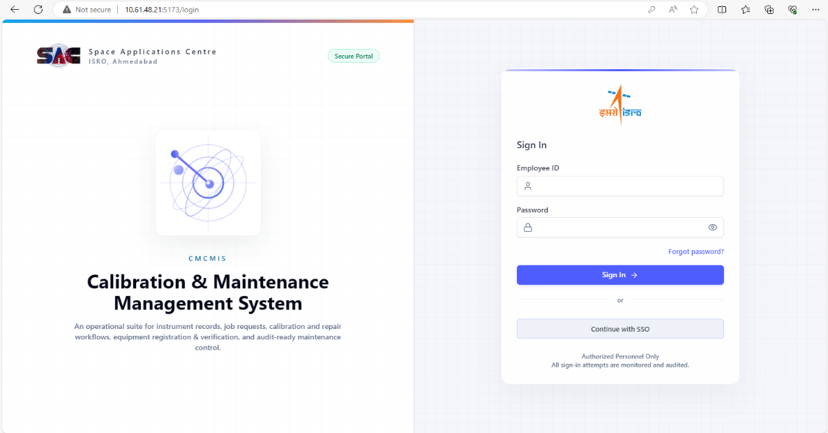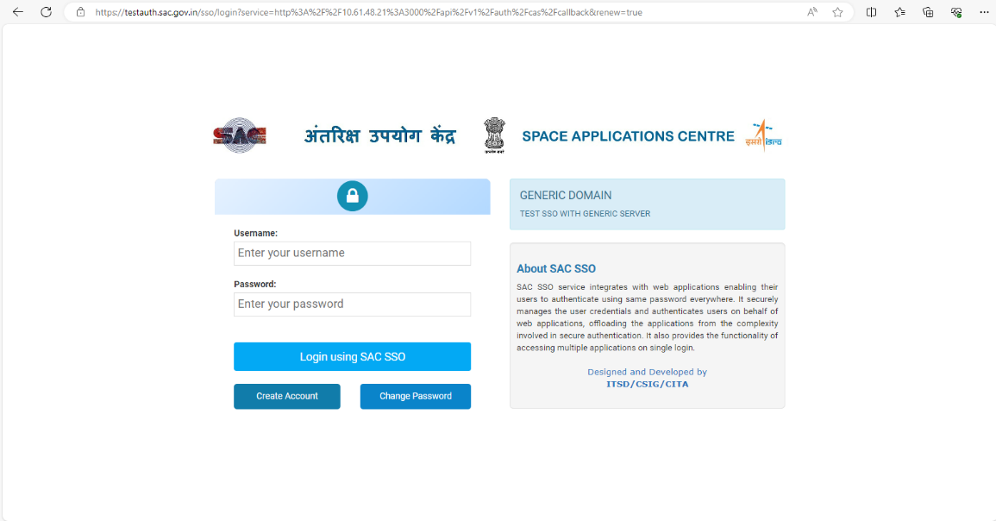

Role-Scoped Dashboard & KPI Cards:
Dashboard view tailored to Lab In-Charge role showing pending approvals, in-progress jobs, and calibration-due alerts

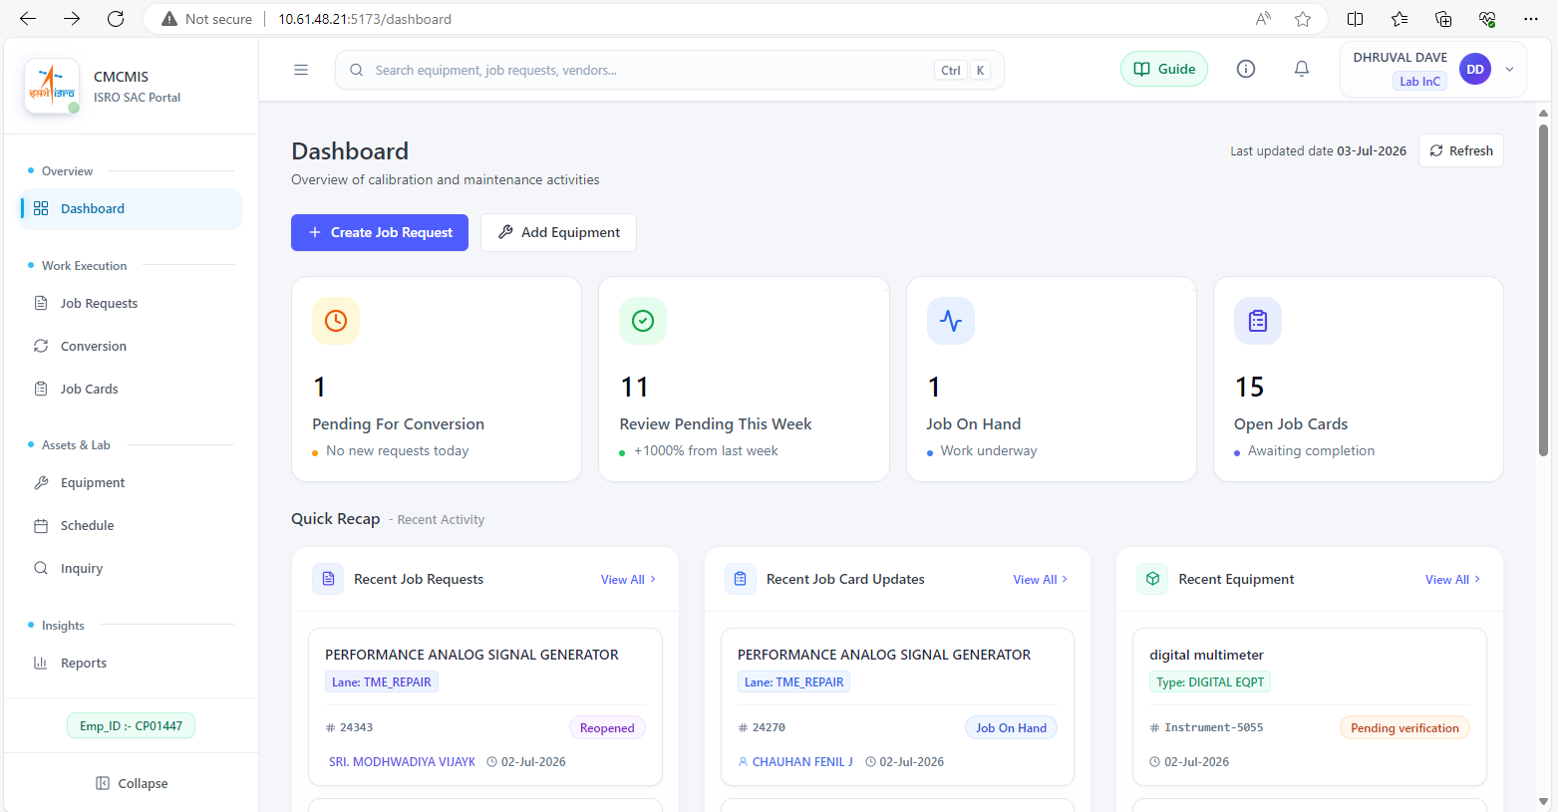

Equipment Register — List View:
Paginated equipment list with search, filter, and calibration-due status indicators

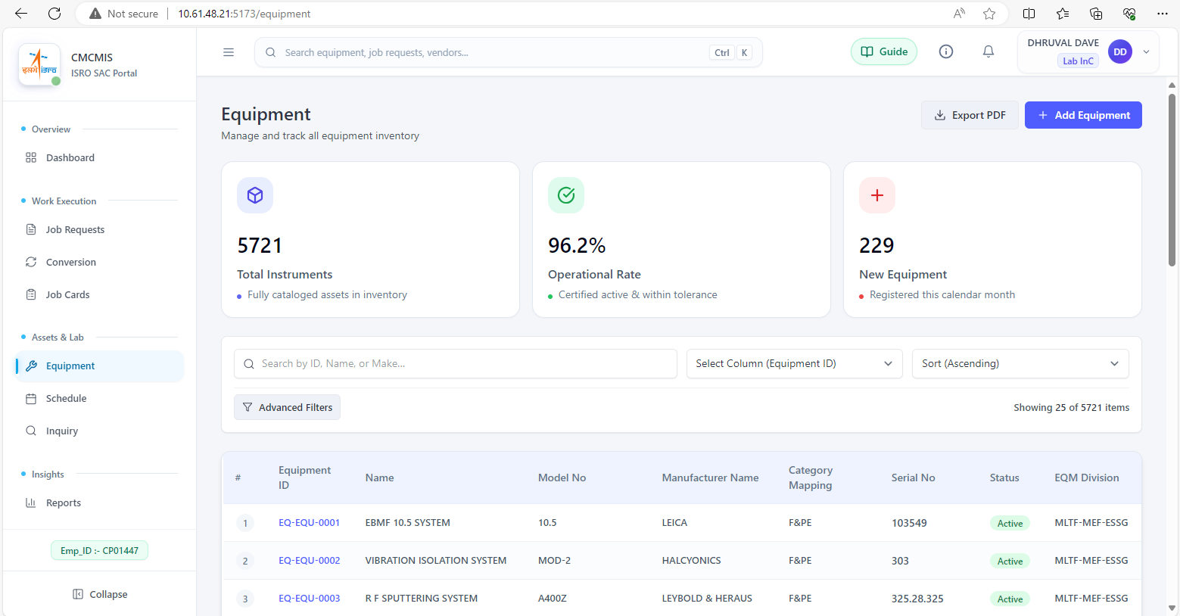

Equipment Register — Registration Form:
New equipment registration form with type/make/division/project lookups

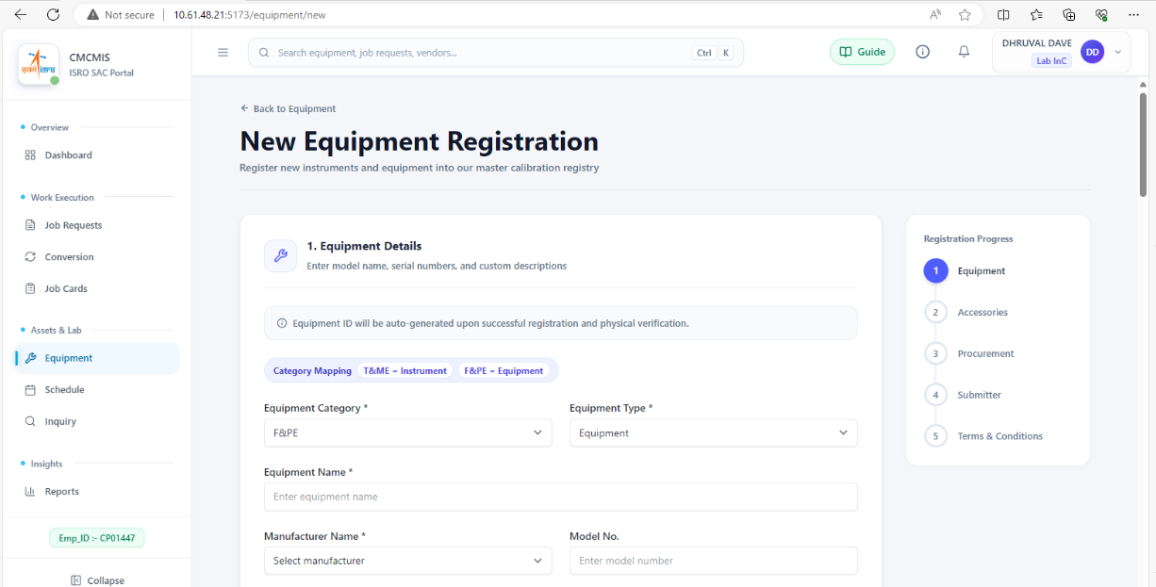

Job Request — List & Status View:
Job Request list showing multi-role status badges and action buttons per role

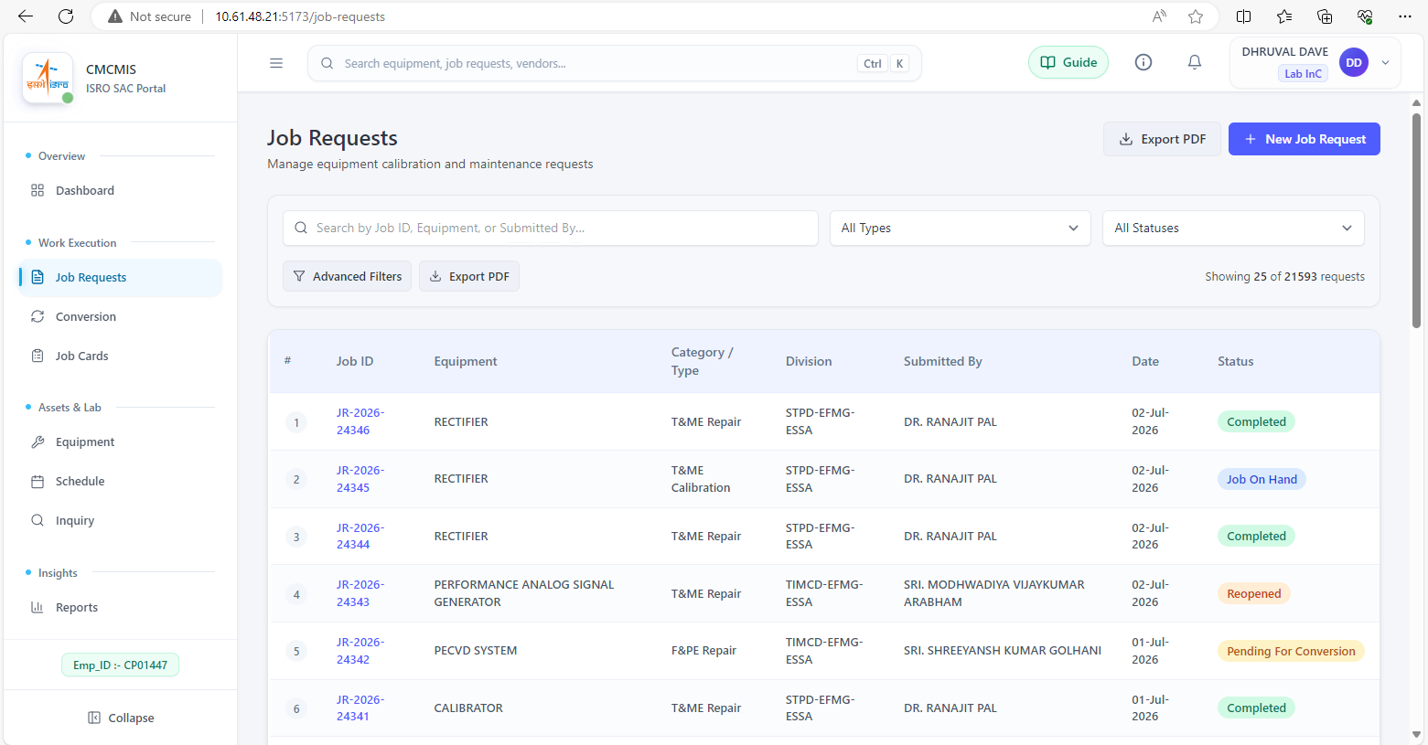

Job Request — Creation Form:
Job Request creation form with equipment type-ahead, work-type selector, and accessories

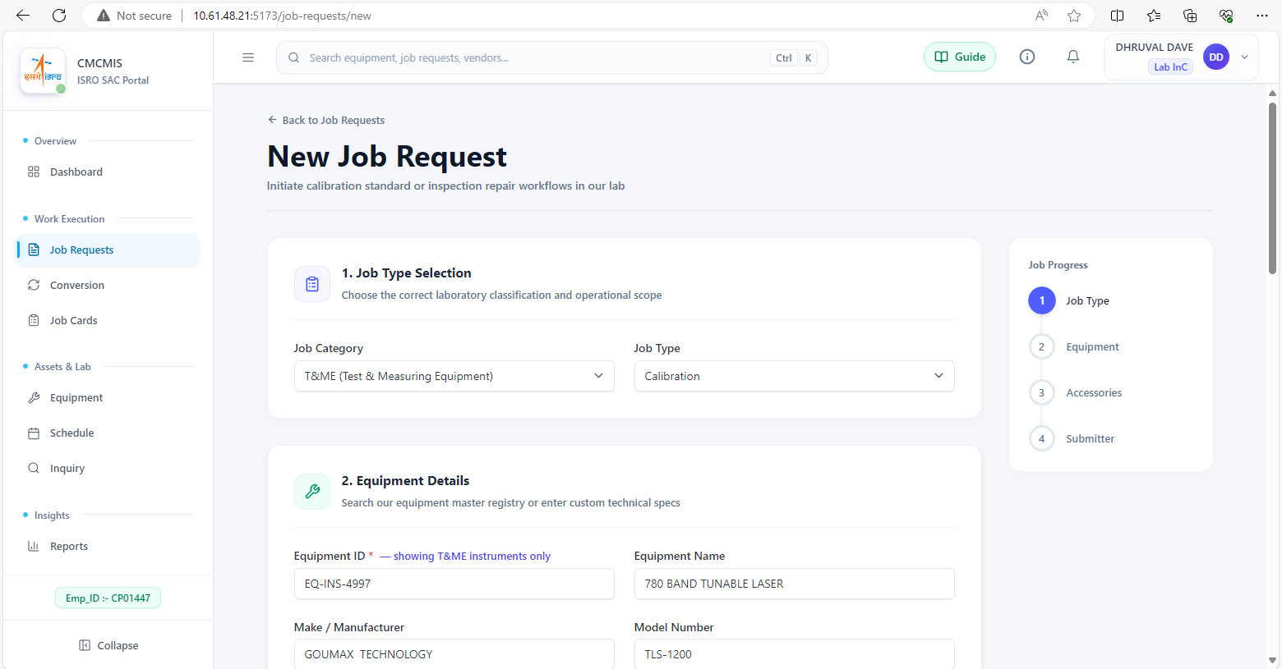

Job Card — Detail View (Calibration tab):
Job Card detail screen showing the Calibration sub-workflow with equipment-used and adjustment-rows

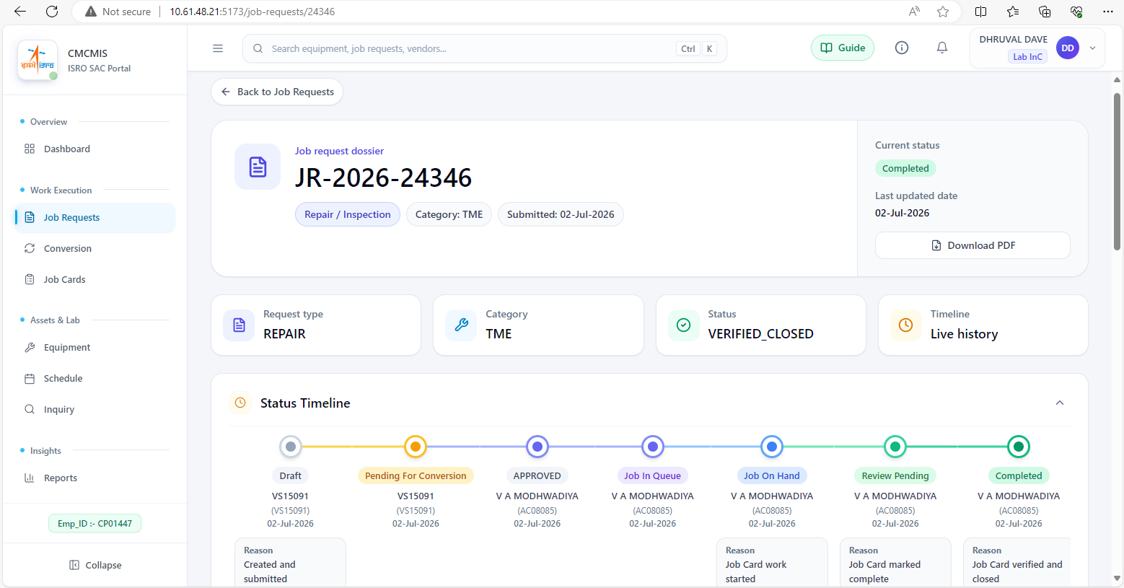

Job Card — Detail View (Checklist tab):
Job Card checklist tab showing applied tasks and pass/fail completion tracking

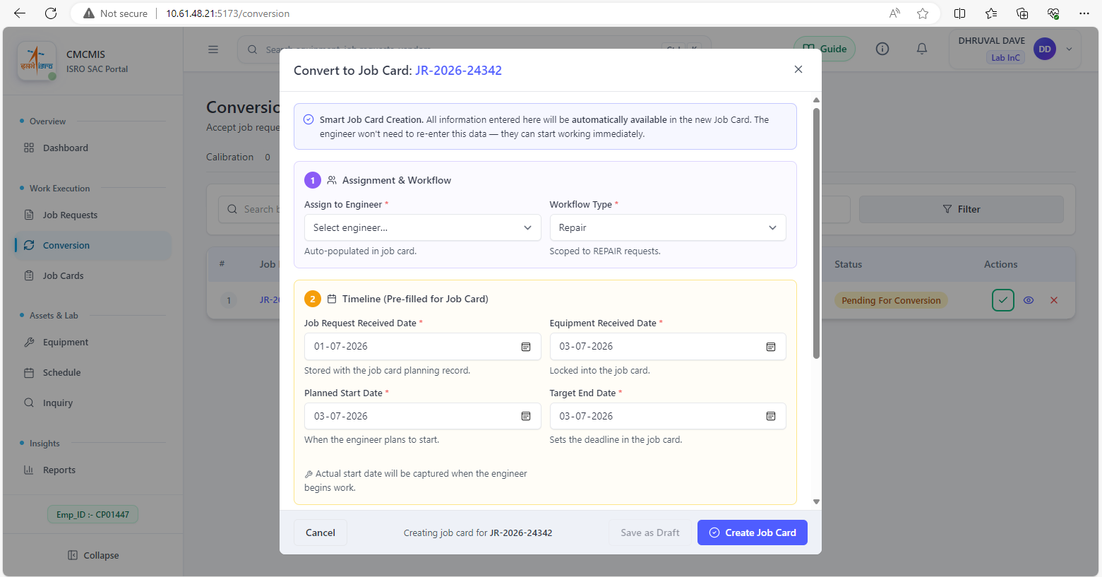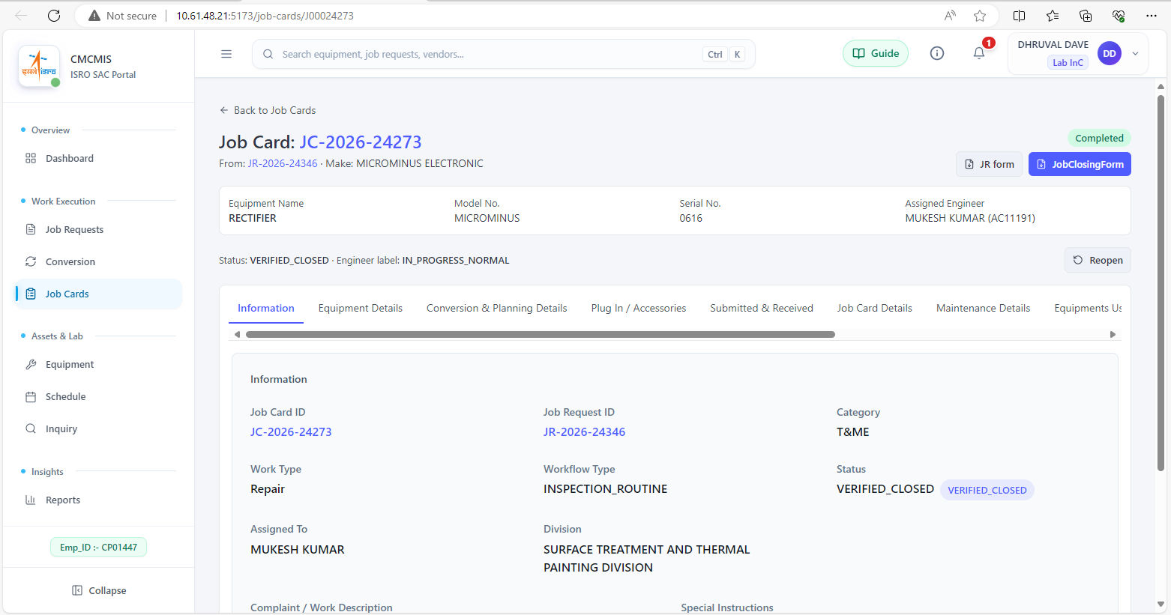
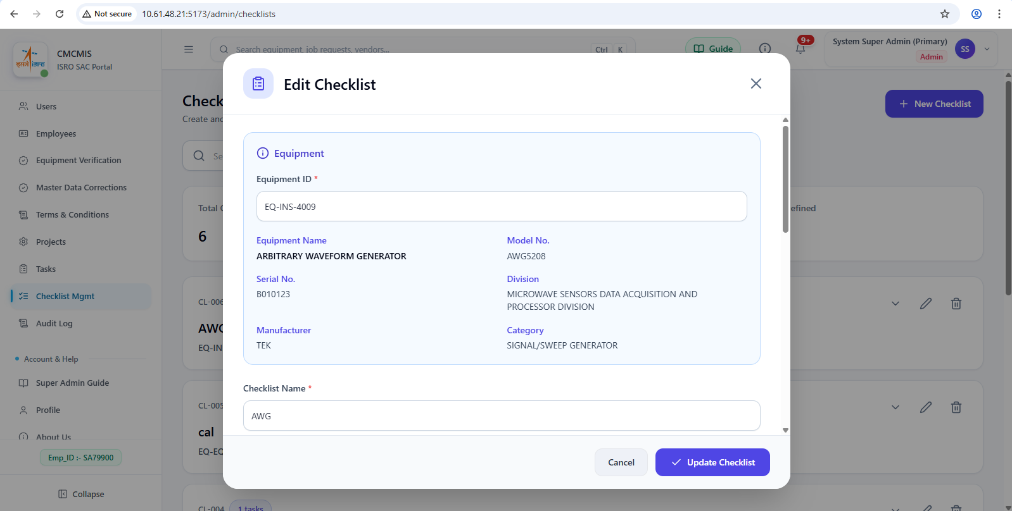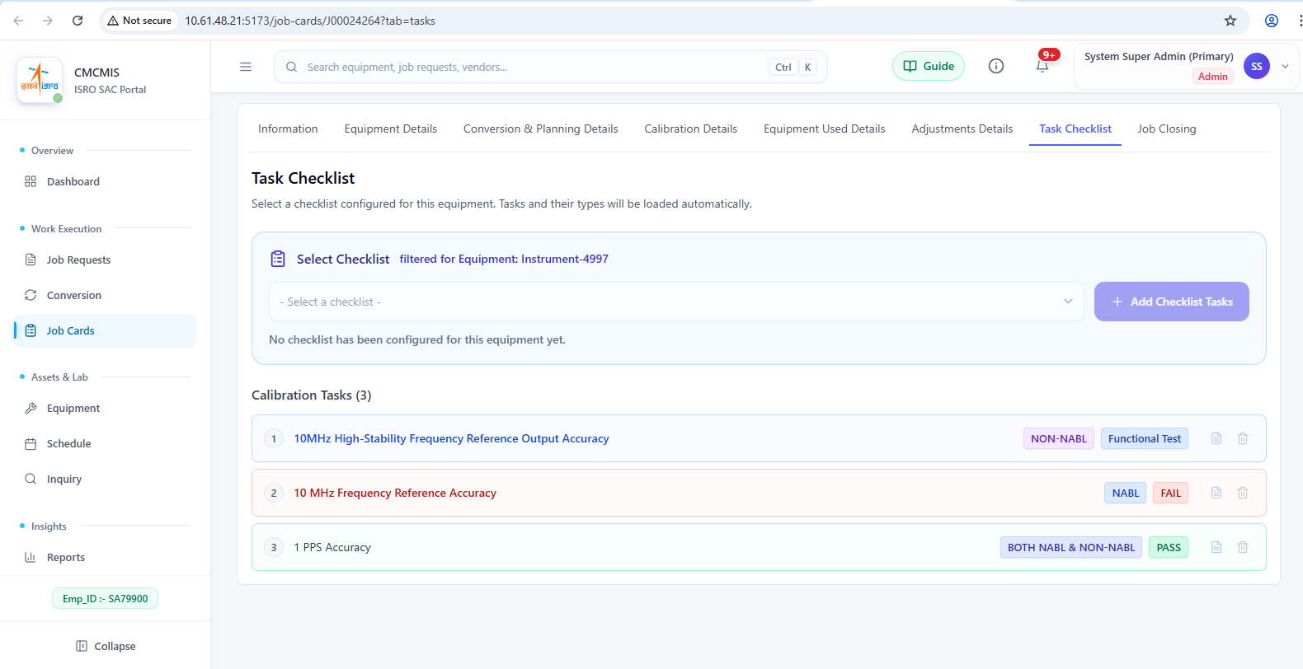
Certificate Generation (NABL, NON-NABL, Standard Certificate, Job Closing Form)
Generated NABL-accredited calibration certificate PDF preview
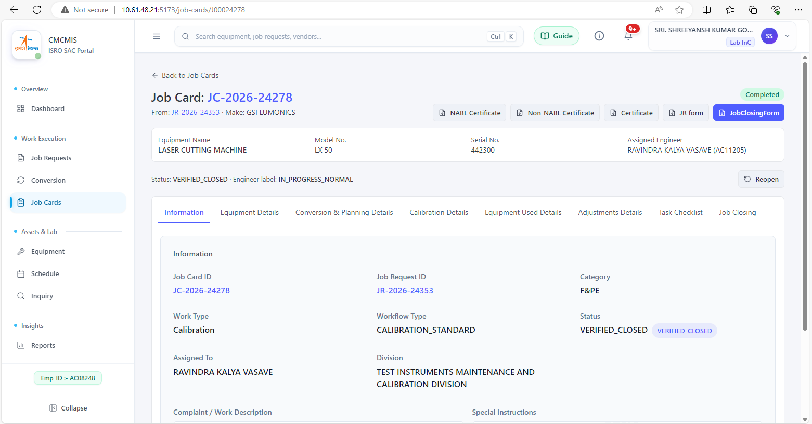
Reports — Calibration-Due Report:
Calibration-due report with date filter, summary tiles, and table view

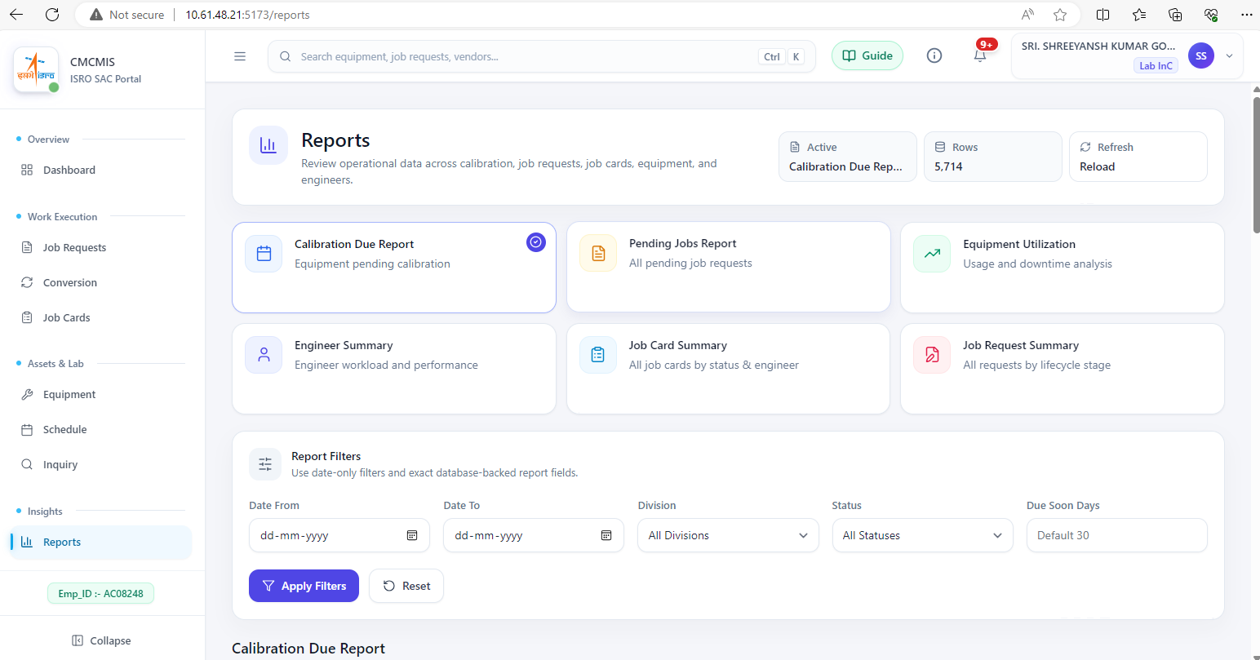

Admin Console — User Management:
User account administration showing role assignment and activation controls

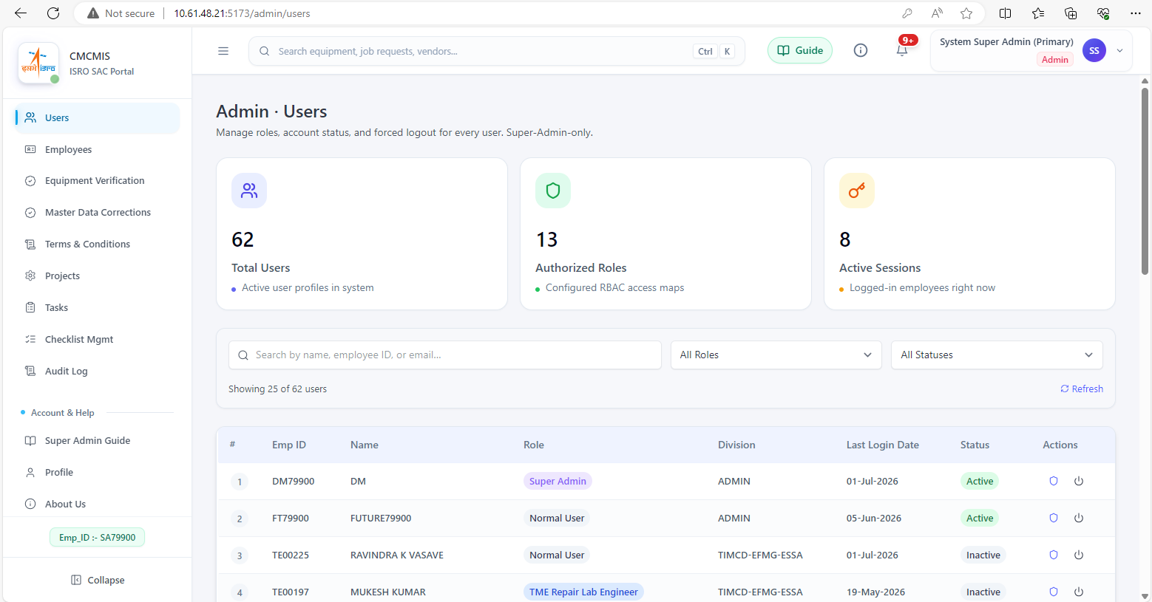

Audit Trail Browser:
Audit log browser showing filtered log entries with field-level change detail

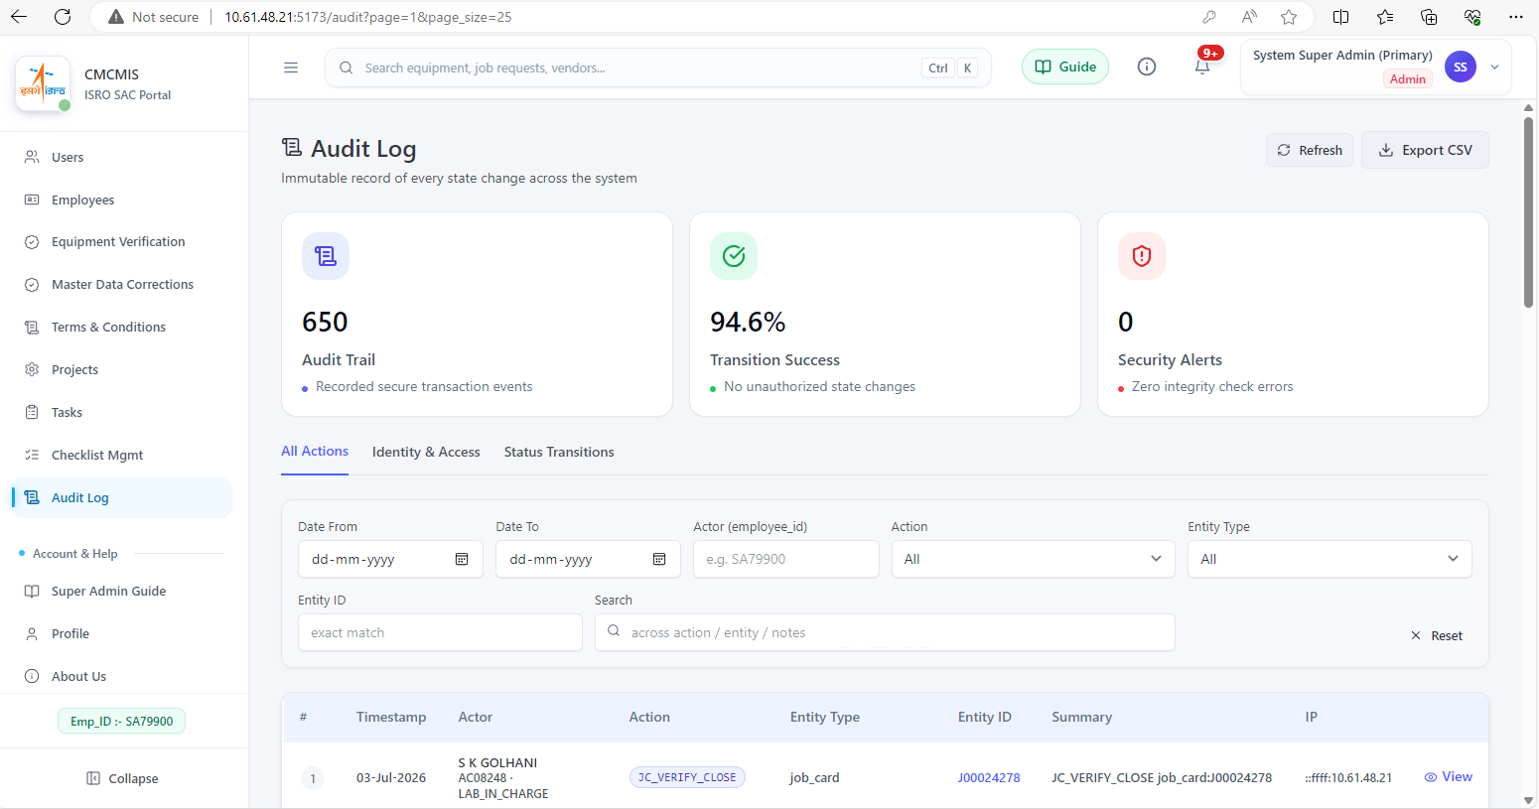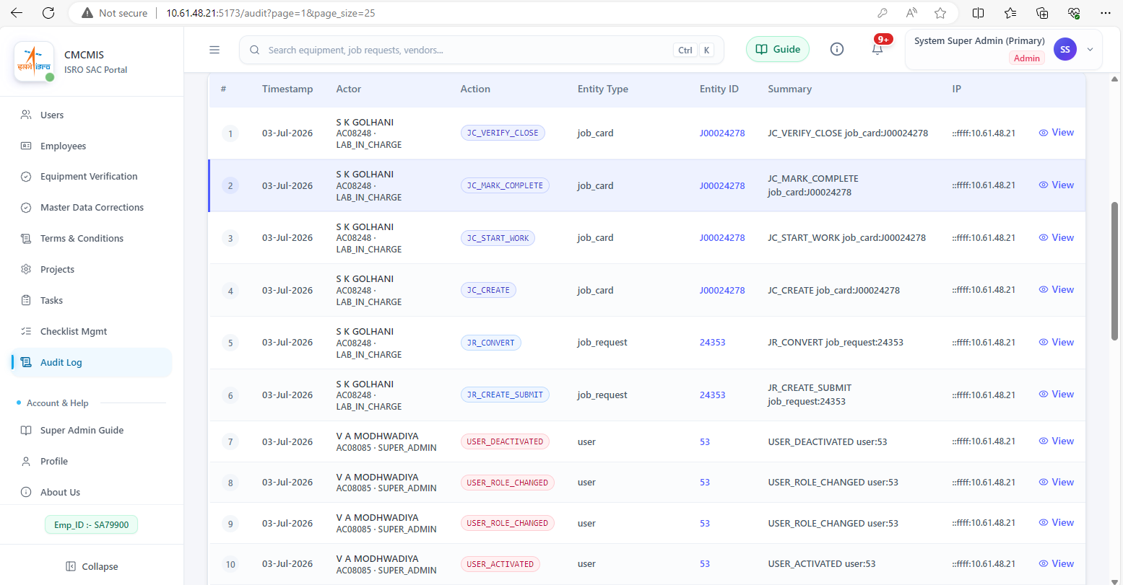

Schedule / Lab Calendar:
Lab activity calendar with ICS export option

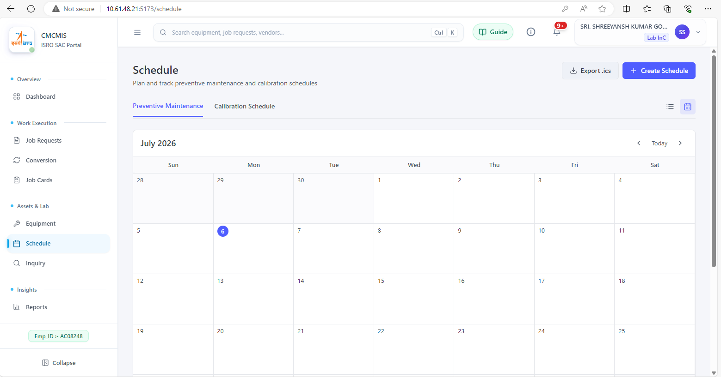

Appendix B: Sample Deliverables
Calibration Certificates (after redevelopment):
 | 

Job Request and Closing Forms:
 | 